Debug Evidence

Bug 1
When player wins on 1 match, balance does not increase.

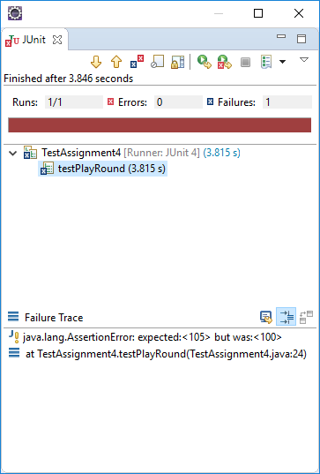
Resolution:
Corrected winnings = bet * matches + bet

Bug 2
Player cannot reach betting limit

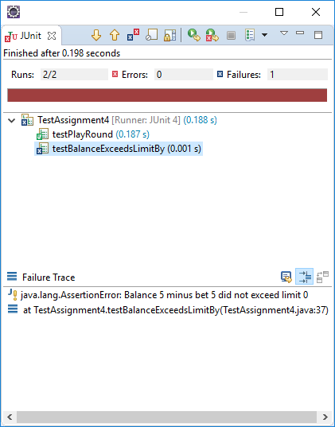

Resolution:
Corrected balance exceeds limit by to be equal to or greater than limit

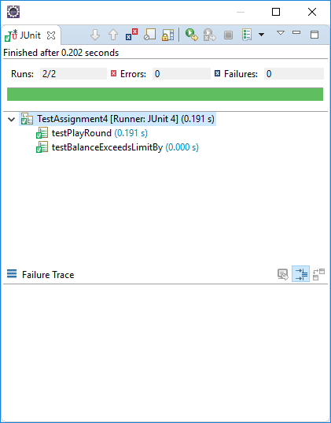
Output from main:
Fred won 5, balance now 5

Turn 138: Fred bet 5 on ANCHOR
Rolled CROWN, CROWN, CLUB
Fred won 5, balance now 0

138 turns later.
End Game 99: Fred now has balance 0

Bug 3
Odds in the game do not appear to be correct.
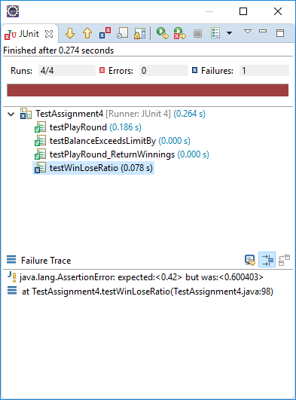

Resolution

Bug 4
Winnings are reported as bet amount on a loss

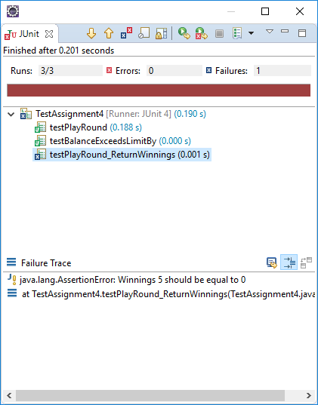

Resolution:
Moved winnings calculation inside if matches > 0
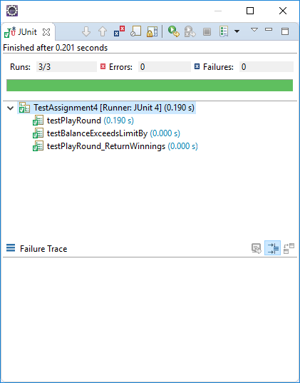
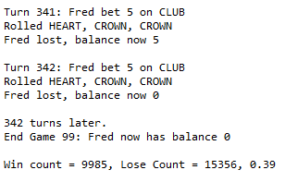
Game is now actually lost, given correct winnings:

